***Valazo Scarves For Men***

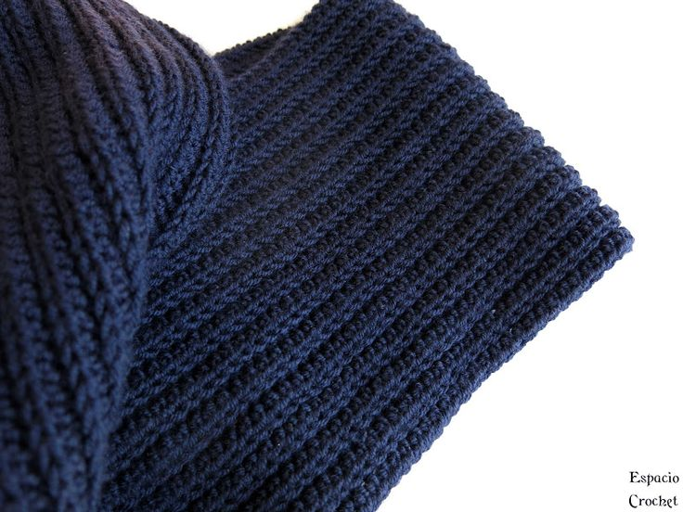

*Very thick and smooth scarf is the most meaningful gift of all to replace your words of love in the cold winter.  
- Luxurious and sophisticated, extreme western color never goes out of fashion.  
- Wide scarf has many unique styles or becomes a very luxurious shawl.  
- The fleece material is soft, smooth, and keeps warm well  
- Suitable for both Men and Women, can make couple and group clothes. Scarves are easy to wear, easy to coordinate with many styles, suitable for everyone  
– Scarves Meaningful gifts for relatives and friends.*